topic |  |  | Plantar Fasciitis
Procedure |  |  | Release of Plantar Fascia
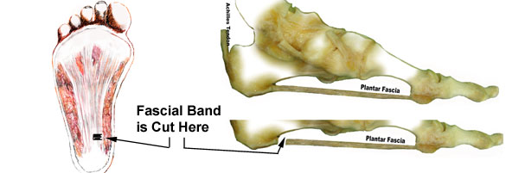
AIMS OF SURGERY |  | To decrease pain by releasing the tight medial/central plantar fascia band
advantages of THIS OPERATION |  | A relatively short procedure  Minimal recovery time
SPECIFIC RISKS of THIS OPERATION |  | Thickened and/ or tender scar  Areas of numbness  Recurrence  Increased flattening of foot - mid-arch pain and lateral foot pain.

OVERVIEW
Operation time | Usually about 15 minutes
Incision placement / stitches | Usually on the inside of the heel with absorbable stitches where possible
Procedure | A short incision is made on the inside of the heel on the non-weightbearing surface. The plantar fascia is identified and cut.
Fixation | None required
Will I have plaster? | no
Is this a Day Procedure? | Yes, you can usually go home the same day (you will usually be admitted for half a day)
Estimated time off work | Non-manual work approximately 2-4 weeks  Manual work 4-6 weeks
INDICATIONS FOR The procedure | Problematic heel pain associated with plantar fasciitis which is unresponsive to non-surgical intervention and where normal work or lifestyle is severely impaired. This surgery is not undertaken regularly, as most people have significant relief from non-surgical treatment.
ALTERNATIVE TREATMENTS | Manage your symptoms by altering activity levels, using painkillers and anti inflammatories, changing footwear (including bespoke), using an insole or orthotic foot support, tension night splints, taping, calf stretches, steroid injection, shockwave therapy.
GENERAL RISKS OF SURGERY | The general risks of foot surgery are outlined in the Pre-operative Information Booklet which is provided in addition to this leaflet  YOU SHOULD READ THIS LEAFLET IN CONJUNCTION WITH THE PREOPERATIVE INFORMATION BOOKLET
MORE INFO By: | 1 Speaking with your consultant or one of his team  2 Reading the information provided

Plantar Fascial Band Release Surgery

The operation can be performed comfortably under a Local Anaesthetic block, which is achieved by either a series of injections around the Ankle, or an injection behind your Knee. You will be fully awake during the operation and will be able to feel touch, pressure and vibration, but you will not feel any pain. If you do not wish to consider having the operation performed whilst still awake, or your Consultant does not feel this is the best option for you, you will be offered Local Anaesthetic with sedation or General Anaesthesia. If this is the case then you may need to be referred to a different surgical team to facilitate this and your consultant will be happy to discuss with you further.

The operation takes about 15 minutes although you will be in the Day Surgery unit for some time before the surgery and afterwards, to allow you an opportunity to rest post operatively. You must have a competent adult at home for the first day and night after surgery. This allows us to be sure you will be safe for the first night.

First 2-4 days
- This is when you will experience pain but you will be given painkillers to help. You must rest for 2-4 days.
- You will be able to stand and walk on your foot after the operation.

One week after surgery
- You may need to attend for your foot to be checked and re-dressed.
- You may start to do a little more within pain limits. An increase in Pain may mean you are doing too much.

Two weeks after surgery
- You must attend again. Sutures will be removed
- You will not need a bandage and can get the foot wet.
- Many patients return to shoes after 2 weeks.

Between 2-6 weeks after surgery
- The foot starts to return to normal and you can return to shoes.
- The foot may still be quite swollen especially at the end of the day.
- You may return to work but may need longer if you have an active job
- You may return to driving if you can perform an emergency stop. You must check with your insurance company before driving again.
- Whilst normal activity will be resumed, sport should be avoided.

Between 8-12 weeks after surgery
- The foot should continue to improve and begin to feel normal again.
- There will be less swelling.
- Sport can be considered after 3 months depending on your recovery.

Six months after surgery
- You will have a final review between 3- 6 months following surgery.
- The swelling should now be slight and you should be getting the full benefit of surgery.

Twelve months after surgery
- The foot has stopped improving with all healing complete.

Please note, if a complication arises, recovery may be delayed.

